FINAL EXAMINATION
TIME ALLOWED: 90’
Subject: Linear Algebra. No books allowed.

1/ Find all complex number z such that 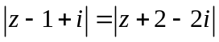 and 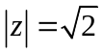.

2/ Determine all real value(s) m such that 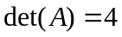, where
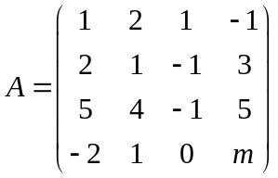.
3/ Solve the linear system 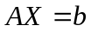, where 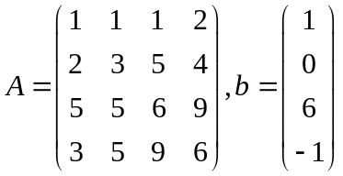.

4/ Find the matrix X such that 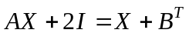, where 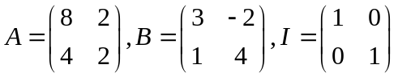.

5/ Given the inner product in 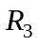 as follow:
.
Find the length of the vector 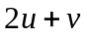, where 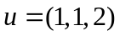 and 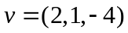.

6/ Let 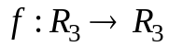 be a linear transformation. Given that .
a/ Compute 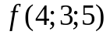.
b/ 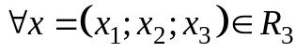, find 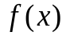.

7/ Diagonalize (if possible) the matrix 

  

